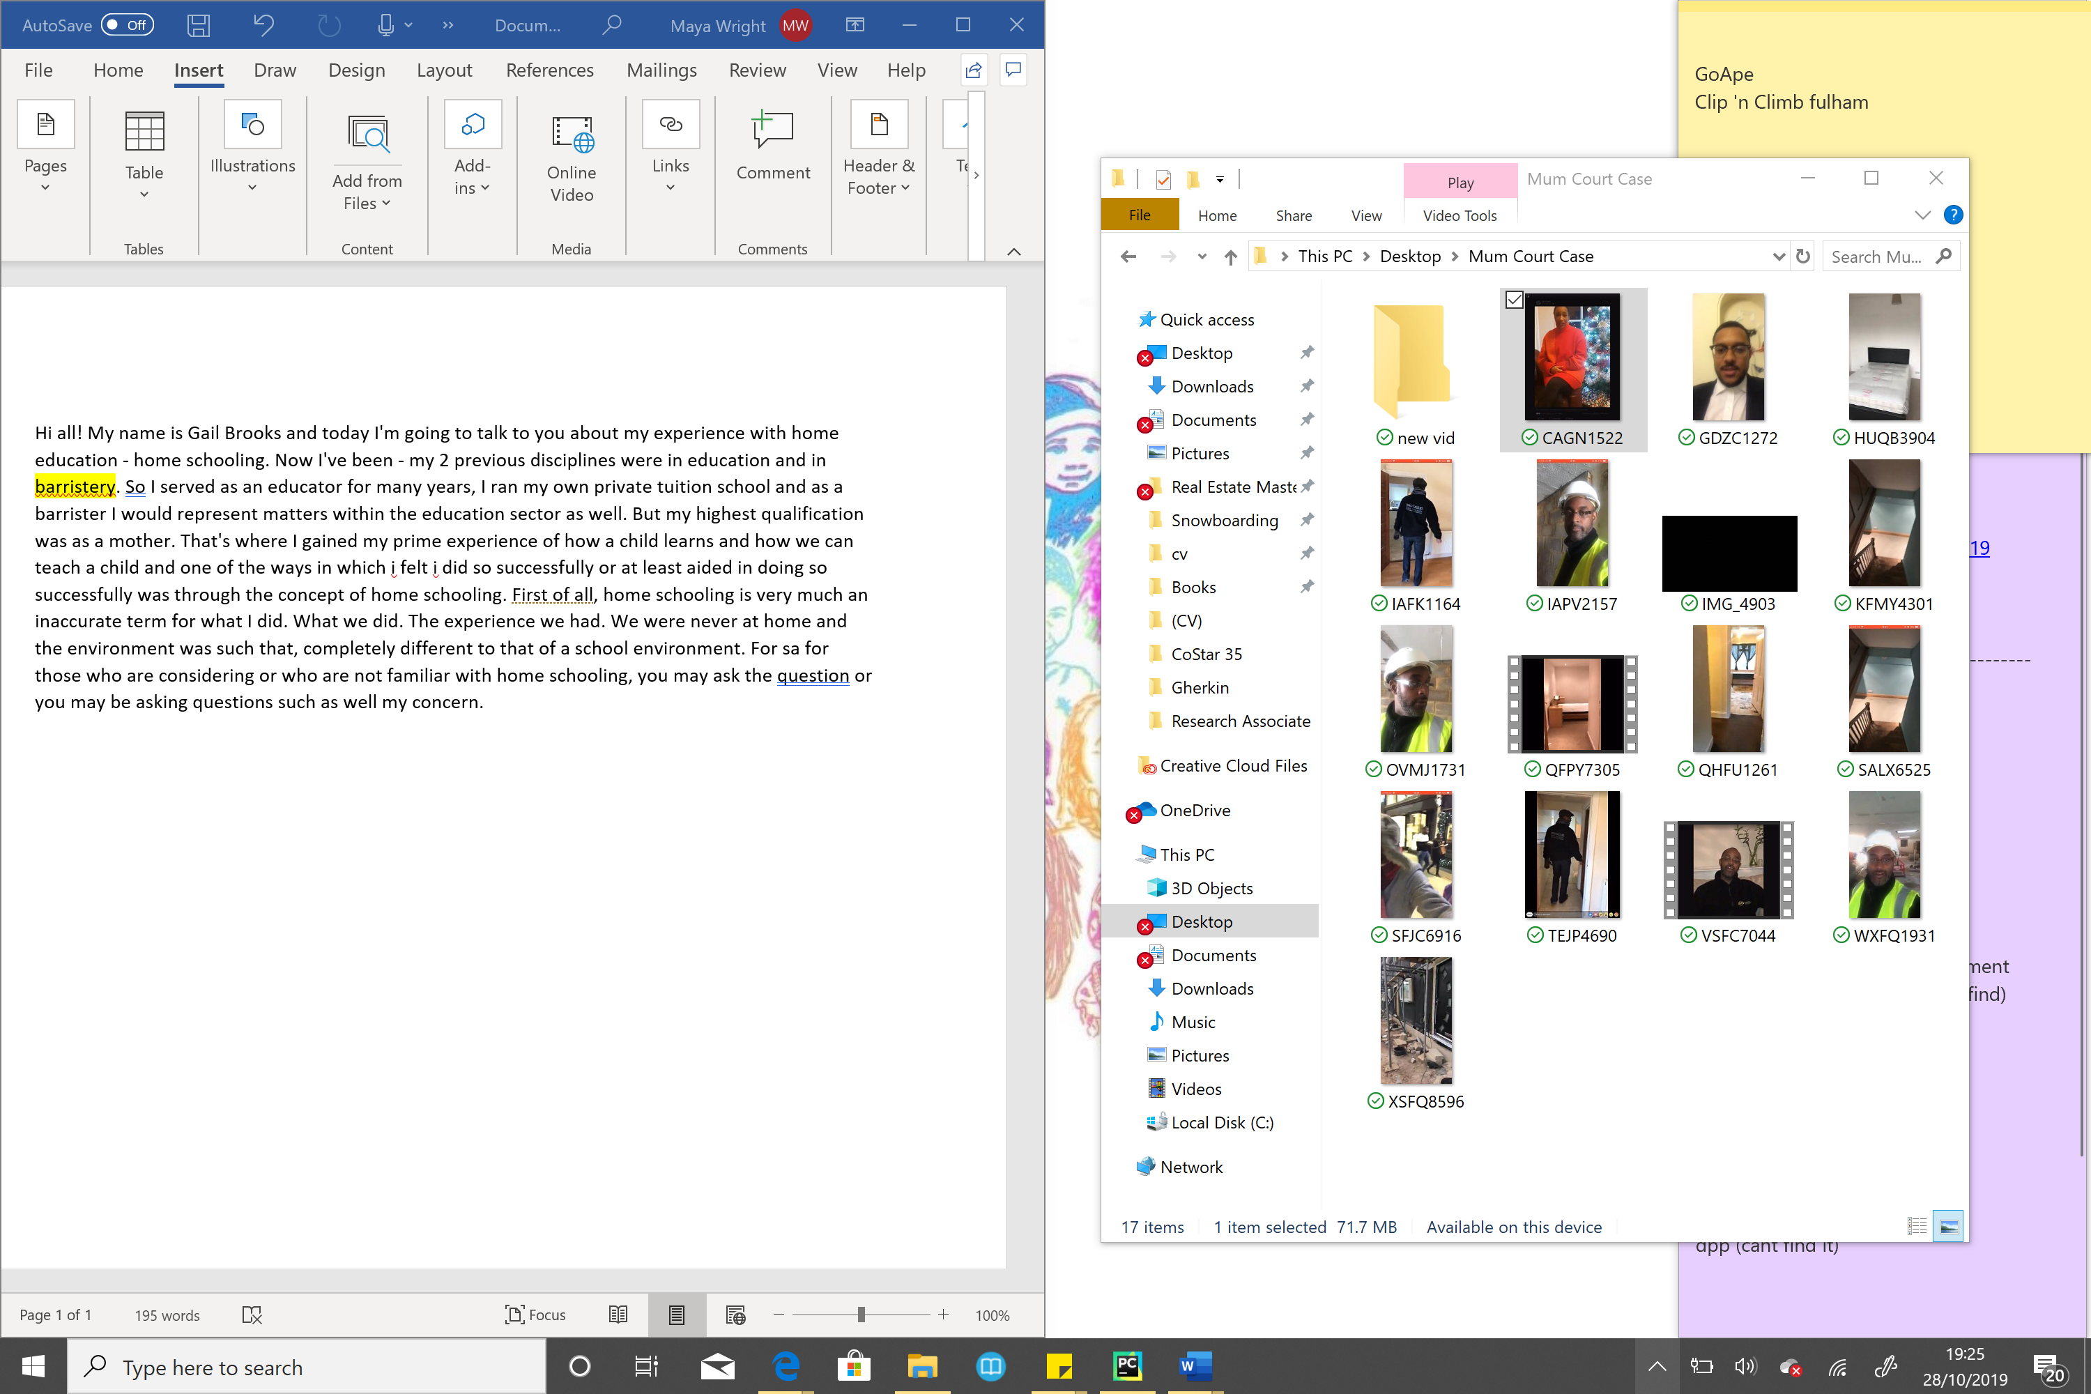
GAIL TALKING ABOUT HOME SCHOOLING
Hi all! My name is Gail Brooks and today I'm going to talk to you about my experience with home education - home schooling. Now I've been - my 2 previous disciplines were in education and in barristery. So I served as an educator for many years, I ran my own private tuition school and as a barrister I would represent matters within the education sector as well. But my highest qualification was as a mother. That's where I gained my prime experience of how a child learns and how we can teach a child and one of the ways in which i felt i did so successfully or at least aided in doing so successfully was through the concept of home schooling. First of all, home schooling is very much an inaccurate term for what I did. What we did. The experience we had. We were never at home and the environment was such that, completely different to that of a school environment. For sa for those who are considering or who are not familiar with home schooling, you may ask the question or you may be asking questions such as well my concern.

(SALX6525) doesn’t have sound

GARY WALKING ROUND A 4 BED HOUSE WITH BASEMENT THAT WILL BE CONVERTED TO 7 BED
Hi Everyone. Gary here again. Right Broga UK. I just like to say, that its been an awesome week. Its been an awesome time in fact. I just picked up another house. Which is fantastic. I’m gonna show you it. Big house. Um, just got the keys right here, which is beautiful I'm going to turn the camera around so you can actually see what i'm looking at. OK, right so this is the house here, this is the front of the house. As you can see there, and we were going to walk through we got in the back. It’s a beautiful four bedroom but I have created will create several rooms out of it. Now this is a hallway as you can see here we are just having some, the furniture’s just arrived. Um I've got someone here putting it together. This is one of the rooms, quite a big room here, a beautiful fireplace and you can see the arm cornish's up there just beautiful beautiful. And then we've got the other room which leads straight out into the back garden. Got another huge fireplace here, a huge room. I'm I'm considering splitting this one in half which I can and creating two more rooms out of this. So basically there's going to be about 3 rooms down here on this level. Now this toilet I'm going to convert into a shower room as an extra shower room. As you can see there's a back door there. Were going to go through. I've also got the basement, which I I'm going to convert potentially going to do this as 1 self contained. As you could see and this is the toilet- a usable toilet and bathrooms and this is, I'm going to use as a front room down here. Good space. Right we've got another room, so its gonna be like the bedroom in here, possibly. We’ve got a little storage space through here. I love this. I love this house. It’s old and it's nice and it's got loads of space. But I'm really coming together. Now here we are we’re going through to the kitchen dining area as you can see through here. Another good sized space. This is the kitchen we're going to be putting a sofa, a table and possibly TV out here. This goes out to the back garden. Again its a big back garden as you can see it's a bit dark out here but you can just about get the gist of it. As you can see just by getting the gists of it there's a big back garden and we got 3 doors to come out here. I wont waste too much time out here. Right now we're going to go upstairs. Go Upstairs which is where we got another 4 bedrooms up here. Now there's another toilet here and this is a beautiful bathroom with walk in shower. As you can see it's just great I love it. And we go back upstairs here and now we've got one of the smaller bedrooms. Which is still awaiting bedroom furniture. Another bedroom here. The TV – well a guy’s working here doing his bit. His a bit shy but never mind and this is the room that's been taken already. Which is, and this one has got the ensuite. As you can see, big huge windows. Right I'm actually quite pleased with this house here um there is another. This is another room here and we have had another viewing today as well. And this room, not this one - that one over there is going to be taken so yes that's it. OK well on that note it has been a great weekend actually. I think I'm very blessed and very lucky to doing this. And I thank all the people that ive met with progressive crew, the FL crew, Liam. And yes well this is it so great and I feel really blessed and hope to keep moving forward and learn a lot more. Okay then well on that not, I'll pick you guys a great weekend or rest of it and have a fabulous week and everyday it's an awesome day right so take care cheerio.

GARY SITTING ON SOFA IN BROGA FLEECE
Hello I’m Gary Brooks very nervous about doing this not used to it at all. So im trying to get comfortable with being uncomfortable. Now I have a construction and property investment company called Broga UK. Now it’s not what I want to talk to you about. What I do want to talk to you about is the fact I've been offered an amazing deal today I couldn't believe it. Um It's a Pub it's got planning permission for five, two bedroom flats, are minimum size 3 of them -74 square metres. One 75 the other one 79 square meters. The ground floor which is the pub which is potentially going to be a pub if you wish it to be but Um is 113 square meters. Now I've been offered this one million five thousand. Now the flats in this area are going for 425 ranging from 425 thousand up to 5500 thousand pounds. Now the property the property is located in Croydon and is literally 10 minutes away from the main stations East Croydon, West Croydon, the 2 and the bus station and tram link. Its literally that's it 10….. 10 minutes away from each one of those areas. Um Croydon is actually injecting 1.4 million Billion pounds into regenerating the retail sector which is a lot of money and they're bringing Westfields down and many other retail department stores. Now I believe that this Croydon is actually going to go up in price in property and whilst this development is in progress the prices of the property will rise so the price I'm telling you now the profit margin the gross profit margin now is what it is now, but later on in a year's time it may actually increase to more, a lot more. So I'm just, would be happy if anybody is interested to work with me alongside me as a JV great please let me know and feel free to contact me at your earliest convenience because this deal is actually……………..um……… what can I say? It is…….. It is……… I've lost for words now. You see I don't know what to stay, but it's just a good deal and people are people are banging on this guy's door but he seems a very nice genuine geezer and yes I think he’ll like me to have it.

VIDEO STARTING FACING A LIFT
Hello. This is Derby Riverside apartment. As you can see you’ve got a staircase, you got a lift straight to the front door. As we walk through, this is the hallway. We have a lovely bathroom there. To our right we have the first bedroom. Which has an ensuite. And if we look outside it's beautiful views I know its a little bit dark but here we are. That’s the River down there, see the church over there. This is the ensuite apartment. As we walk through the hallway, very large hall. We have the second bedroom. The bed which has storage underneath as you can see. Another beautiful view. And we have 3rd bedroom. In this cupboard to the left we have storage. Play around. And that bed there is a a optimum bed so it actually got storage underneath the mattress you lift the frame. Lets go upstairs to the kitchen diner. In front of us we have a balcony with a barbecue and it is a bit dark so you can't truly see it. This is the kitchen diner and we have another balcony out there which overlooks the River. Washing machine, beautiful kitchen. Take you back downstairs, one more view. Back into the ensuites. Heres the large bedroom so you could see one more time. Back into the last bedroom. Hope you like the apartment please give me a call if you're interested. Two rooms, three rooms are available. Thank you.

VIDEO of Gary walking down the street has no audio
(No audio)

Second HMO in Streatham
Alright folks. Iv got my second HMO, rent to rent. Lovely area look at the view. We’re in what? Streatham. It’s beautiful. This is the house. Alright we’re just going to go in now. We’ve got a four bedroom house. Potentially seven rooms. This whole drive holds about 3 cars or so. Do the front door. This is actually really nice. Check this out this huge lovely hallway and here's our first room. Sorry my camera ladies um. Here's my first room, not bad size room. Not a bad size room, this room. This right here we are going to do one whole room. Very good size room needs a little clean up washing the curtains but those are very minor stuff. I'm very pleased with the open space. Lets take a look at the garden it has a nice huge garden as well. Good size anyway, its beautiful. Im quite pleased with this. With this one. And this is the kitchen area. I think these doors are really nice. The kitchen area. And we have a small utility area in here, out here. With another back door leading to the garden. Leading to a garage. And another little toilet, it also even has a little [inaudible] but also even the little hose. Alright here we go let's go upstairs now. [inaudible] I really do like the kitchen. [inaudible] lovely spacious hallway I'm going upstairs now in the bedrooms. Right now this is where we are the first master bedroom, quite big one. Look at this size, really nice. Got some fitted wardrobes as well. In here, so I wont have to be purchasing any wardrobes. Good Space, fitted wardrobes all the way through, save me some money. Nice curtains. Im very pleased with this one here, I think it’s a very nice house, its got lots of room and um its in a nice area aswell. Not too far from the train station, the park just down the road, the bus facilities - really convenient. We've got streatham down bottom we've got Brixton and west Norwood a mile or 2 miles away. Here is the bathroom. Needs a little bit of a tiding up but we’ll do that in time and do over the next few days. This is one of the other bedrooms we've got more fitted wardrobes you can see some storage space in here as well, so loads of storage. One of the other smaller rooms, another little toilet not bad. And this is a small room, which can hold a double bed and maybe a chest of draws which ideal space. Overall im actually quite impressed with this one. I'm actually going to view another one and that's further in nearer to Streatham common. And I think that we will probably going to take one as well because I saw that one last night. But I'm actually quite impressive, its a very beautiful house and I hope you like this video its one of my second life videos which I'm not very used to and um but this this is it. Okay then, well that’s it then.

BLACK CONSTRUCTION HAT
Hi Gary here from Broga UK. Just doing another video. I haven't been doing a video for a little while. I'm on one of my sites actually. Um, 8 new builds and 3 bedroom properties. Yeah let's take a quick tour.

